Planning Phase

During the Planning Phase, solo ships are not assigned dials.

System Phase

During the System Phase, each solo ship equipped with a Bomb or Mine upgrade card checks to see if it drops that device. The solo ship rolls 1 attack die for each enemy ship at range 0-1, or in its rear arc at range 0-2. If it rolls at least 1 hit or crit result, it drops its equipped Bomb or Mine.

Activation Phase

When a solo ship activates, it resolves an additional step before revealing its dial, the Determine Approach step. This step generates that ship’s Approach and Attitude this round, selecting the maneuver on its dial and determining what action it will perform during this activation.

* Determine Approach: During a solo ship’s activation, its dial is set by comparing its position to that of its Tally,determining which Approach Chart applies, rolling 1 defense and 1 attack die together, and setting the ship’s dial to the corresponding result.

1. Identify Tally: Select an object as the ship’s tally using the following criteria:

1. The nearest object it has locked at any range.
2. The nearest enemy ship in its bullseye arc at range 0-3.
3. The nearest enemy ship in its front arc at range 0-3.
4. The nearest enemy ship in either of its side arcs at range 0-3.
5. The nearest enemy ship in its rear arc at range 0-3.
6. Repeat steps b-e, above, for enemy ships beyond range 3.

2. Approach Chart: Each of the solo ship’s arcs (bullseye, front, side, rear) has a matching approach chart. Gather the approach chart that will be used to select the solo ship’s maneuver based on which of the solo ship’s arcs its tally is in.

1. If the tally is in more than one of the solo ship’s arcs, use the approach chart for the first arc it is in, in the following order: bullseye arc, front arc, either side arc, rear arc.
2. If tally is beyond range 3, extend the relevant arcs using a longer measuring tool, or simply “eyeball” which arc it is in.

3. Approach Roll: Roll 1 defense die and 1 attack die, reading the result on the defense die first, followed by the result on the attack die (i.e. Evade, Hit). Place these dice next to the solo ship to refer to until the end of its activation.

4. Set Dial: Compare the approach roll to the chosen approach chart, and set the solo ship’s dial to the maneuver that matches the entry.

5. Determine Attitude: The results of the approach roll also determines the solo ship’s attitude for its activation. A solo ship’s attitude is used to determine what action it will perform in its Perform Action step, and is also a useful guide when it resolves abilities.

* Evade Result: The ship’s attitude is Defensive.
* Focus Result: The ship’s attitude is Balanced.
* Blank Result: The ship’s attitude is Offensive.

Movement

Barrel Rolls and Tallon Rolls

When a solo ship performs a barrel roll or executes a tallon roll maneuver, it aligns its base so as to best satisfy any “towards” or “away from” requirements of its Approach Chart entry or Attitude while still completing that movement.

Fleeing

Solo ships do not flee the play area. If a solo ship executes a maneuver that would result in it fleeing, it partially executes that maneuver so that it does not overlap the edge of the play area. Then, it is rotated either 90 or 180 degrees in whichever direction will face it towards the center of the play area. It gains 1 disarm token and 1 stress token.

Engagement Phase

Attack Priority

When a solo ship engages, it determines the weapon it will use for the attack as follows:

1. The solo ship attacks with its special weapon with the Lock header that has the highest attack value.
2. The solo ship attacks with its special weapon that has the highest attack value.
3. The solo ship attacks with its primary weapon that has the highest attack value.

Then, it determines the enemy ship it will target with the attack as follows:

1. The enemy ship it has locked that is in the firing arc and range of that attack.
2. The enemy ship it would be able to resolve the most abilities against while attacking.
3. The nearest enemy ship in the firing arc and range of that attack.

If a solo ship has no valid targets with its choice of weapon, it moves on to check for valid targets for the next weapon, etc.

Dice Modification

While a solo ship defends, it will spend tokens and use abilities to modify dice in order to reduce or prevent damage according to the following priorities:

1. Create as many Evade results as possible, up to the number of Hit/Crit results, so that the attack misses or causes as little damage as possible.
2. Spend tokens and use abilities as efficiently as possible, so as to not spend more tokens or use more abilities than necessary to cause the attack to miss (for example, resolving rerolls before effects that change Focus results).
3. If the defender has not yet engaged, and any enemy ship is in the defender’s firing arc, prioritize spending tokens and using abilities that only have an effect while defending (such as evade tokens) before those that also have an effect while performing an attack.

While a solo ship performs an attack, it will spend tokens and use abilities to modify dice in order to hit and deal additional damage according to the following priorities:

1. Create as many Hit/Crit results as possible, so that the attack hits and deals as much damage as possible.
2. Spend tokens and use abilities as efficiently as possible, so as to maximize the effect of the attack (for example, resolving rerolls before effects that change Focus results).
3. If the attacker is in the firing arc of any enemy ship that has not yet engaged, prioritize using tokens and
4. abilities that only have an effect while performing an attack (such as locks) before those that also have an effect while defending.

Approach Charts

When a solo ship uses an Approach Chart to select a maneuver, it selects the maneuver on its dial that matches the corresponding Approach Roll result:

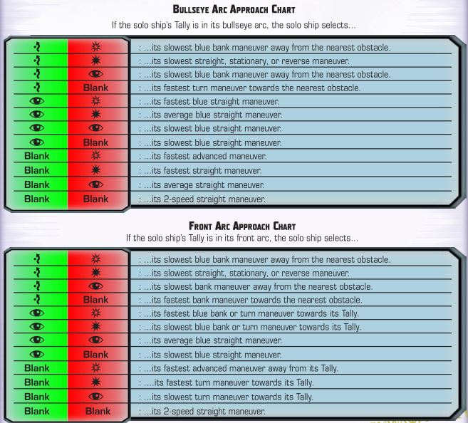

Each entry on an approach chart consists of 2 to 5 details: a speed, a color, a bearing, a direction, and a tally. The solo ship selects the maneuver that corresponds to these details.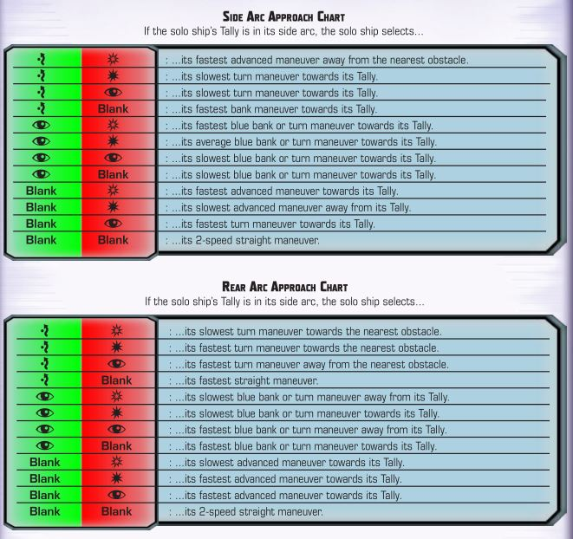

* Speed: As each ship has maneuvers of different speeds, the entries are given as “fastest”, “average”, or “slowest”. These reference the speeds of the specified bearing of maneuver available on the solo ship’s dial. If there are an even number of maneuvers of that bearing, “average” rounds up. The speeds of reverse maneuvers are treated as negative only when determining which is slowest.
* Speed Example: An Imperial TIE/ln Fighter has on its dial:
  + 1-, 2-, and 3-speed turns; which are its slowest, average, and fastest, respectively.
  + 2- and 3-speed banks, with 2 being the slowest and 3 being both the average and the fastest. The 2-speed banks are blue, making them the only option when a blue bank maneuver is required.
  + 2-, 3-, 4-, and 5-speed straights, with 2 being the slowest, 4 the average, and 5 the fastest. The 2- and 3-speed straights are blue, making 2 the slowest and 3 the average and fastest when a blue straight maneuver is required.
  + 3- and 4-speed Koiogran turns, with 3 being the slowest and 4 both the average and the fastest.
* Color: Each entry will either specify that a blue maneuver is required, or not. If a blue maneuver is not required, maneuvers of all colors are available.
* Bearing: Each entry will specify one or more bearings for the maneuver. If multiple bearings are listed, the bearing which best satisfies the other requirements is selected.
* Direction & Tally: Entries for bank, turn, and some advanced maneuvers also have a direction specified as either “towards” or “away from”. For these maneuvers, which could be performed either to the left or to the right, the direction is chosen based on which full side arc the specified object is located. The tally is the object chosen at the start of the solo ship’s Determine Approach step, and is usually an enemy ship. If an obstacle is specified instead of the solo ship’s tally, use the nearest obstacle to the solo ship.

Some circumstances will cause exceptions to the normal process:

* Ionized: If a solo ship is ionized during its Determine Approach step, it does not select a maneuver, and resolves the ion maneuver that activation instead.
* Stress & Red Maneuvers: If a solo ship is stressed during its Determine Approach step and its approach roll indicates a red maneuver that it cannot select or execute, change the defense die to a Focus result instead, as that will select a blue maneuver.
* No Such Maneuver?: Certain very cumbersome ships may lack some bearings of maneuver altogether. If a solo ship has no maneuver on its dial that satisfies the requirements of the entry, change the defense die to a Focus result instead. If that entry also cannot be satisfied, select the ship’s slowest straight maneuver.

Attitude and Actions

During a solo ship’s Perform Action step, the action it selects is determined by its Attitude. If a solo ship does not have access to the listed action, or after measuring it is clear that the action would fail or not have the specified effect, use the next action listed instead.

* Defensive Attitude: The solo ship performs an action as follows:

1. If the solo ship is in at least 1 enemy ship’s firing arc, it performs a Barrel Roll , Boost , or Slam action (in that order of priority) that will move it out of at least 1 enemy ship’s firing arc.
2. The solo ship performs the Reinforce action, reinforcing the full arc that the most enemy ships are in.
3. The solo ship performs the Jam action, choosing the nearest enemy ship with a lock first.
4. If the solo ship does not have an evade token, it performs the Evade action.
5. If the solo ship does not have a focus token, it performs the Focus action.
6. If the solo ship does not have a calculate token, it performs the Calculate action.

* Balanced Attitude: The solo ship performs an action as follows:

1. The solo ship performs the Coordinate action, choosing the nearest friendly ship without Coordinate in its action bar that can perform an action.
2. If there is an obstacle in the solo ship’s bullseye arc at range 0-2, it performs the Barrel Roll or Boost action away from that obstacle.
3. If the solo ship does not have a focus token, it performs the Focus action.
4. If the solo ship does not have a calculate token, it performs the Calculate action.

* Offensive Attitude: The solo ship performs an action as follows:

1. If no enemy ship is in any of the solo ship’s firing arcs, it performs a Barrel Roll , Boost , or Rotate action (in that order of priority) that will cause at least 1 enemy ship to be in any of its firing arcs
2. If the solo ship is equipped with a special weapon with the Target Lock header, it performs the Target Lock action, choosing the nearest enemy ship in the firing arc and range of that special weapon.
3. The solo ship performs the Target Lock action, choosing the nearest enemy ship in its firing arc. If no enemy ship is in its firing arc, it chooses the nearest enemy ship.
4. If no enemy ship is in the solo ship’s firing arc, and any of its Torpedo , Missile , or Bomb upgrades have 1 or more inactive charges, it performs the Reload action.
5. If the solo ship does not have a focus token, it performs the Focus action.
6. If the solo ship does not have a calculate token, it performs the Calculate action.

* Linked actions: If a solo ship is able to perform a linked action or resolve an effect that allows it to perform additional actions during its activation, it will prioritize using those options to perform the most actions in accordance with its attitude.
  + For example: if a solo ship with Barrel Roll , Evade , and Focus -> Barrel Roll on its action bar had a Defensive attitude, it would perform the Focus -> Barrel Roll action if the barrel roll would take it out of an enemy firing arc, as this combination satisfies the highest priority of the Defensive Attitude, even though the Focus action at the beginning of the linked action sequence is a lower priority than the Focus action. If, after measuring, a barrel roll would not take it out of any enemy firing arcs, it would perform the Evade action instead of Focus -> Barrel Roll , as that is the next highest available priority.

ACTIONS AT OTHER POINTS DURING THE ROUND: If a solo ship is given a choice of actions to perform outside of its activation, roll 1 defense die to determine its Attitude for that action.

Card Effects

A solo ship with any pilot abilities, ship abilities, upgrade card effects, or other special rules will attempt to use those abilities as effectively as possible. In general, if a solo ship has the opportunity to resolve an effect that would improve its situation in the game, it will do so.

* Effects that modify dice while defending or performing an attack are relatively straightforward. Solo ships will use them when applicable, and will prioritize using them over comparable token effects.
* Effects that grant additional actions (or equivalent) at specific timing windows require an assessment of whether the action will have any effect on the game. These effects can be pre-measured to determine whether they will fail, unlike for player-controlled ships.
  + Actions that grant green tokens (such as Focus , Calculate , and Evade ) should be used if there is any possibility of the solo ship defending or performing an attack this round.
  + Actions that move the solo ship (such as Barrel Roll , Boost , and Slam ) should be used if they will move the solo ship outside of at least 1 enemy ship’s firing arc that it its currently in, put at least 1 enemy ship in the solo ship’s firing arc, or cause the solo ship to gain bonus dice through range or obstruction while defending or performing an attack against the nearest enemy ship.
  + Other actions and certain situations will require a more subjective assessment. If it is not clear whether the action will have a positive effect, a defense die may be used to generate an Attitude for the solo ship, with actions that threaten or disrupt enemy ships being performed on an Offensive attitude, actions that protect the solo ship being performed on a Defensive attitude, and actions that are ambiguous or that benefit other friendly solo ships being performed on a Balanced attitude.